Institute of Grace July Newsletter

United Methodist Church of the Redeemer sends team of 11 in June.

This team worked with the school children and teachers of Ecole Guerny Filostin and with church leaders and theology students at the Universite de la Grace. They also hosted a time for the children in the community to gather for evangelism and a meal. The school children enjoyed four days with the team while other members of the team worked with 20-30 adult leaders from local churches. We also toured Fort Jacques, The Baptist Mission in Fermathe, and the Musée du Panthéon National Haïtien in Port-au-Prince. The team was the first to stay in the rooms on the second floor of the Guest House as progress continues with that building as well.

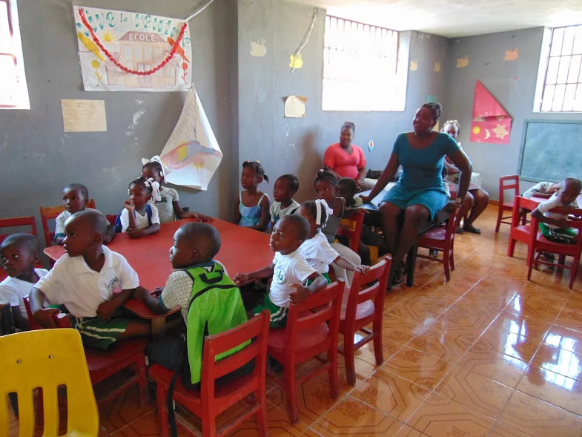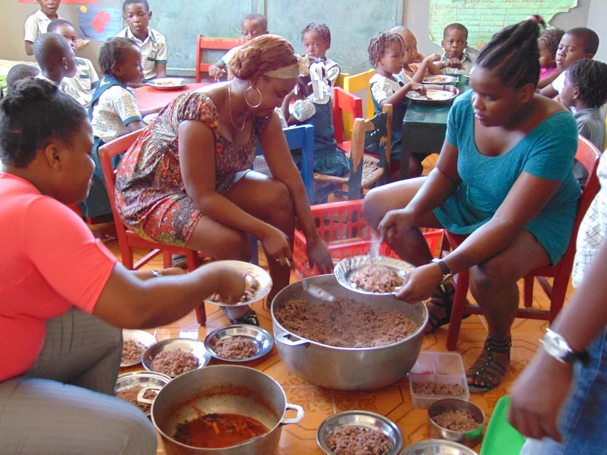

Kindergarten class with their teachers. Lunch is served!

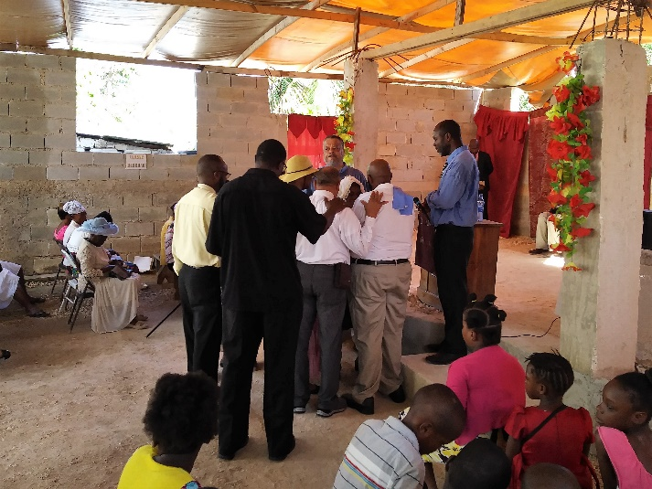 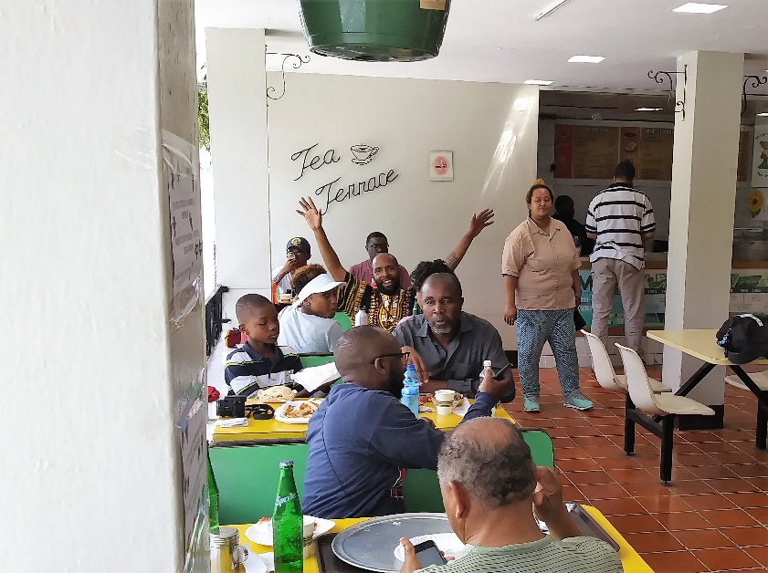

Praying for the sick. Lunch at the Baptist Mission.

Pastors Cleon and Jerome with Junior Desir translating: The team at Fort Jacques in the mountains:

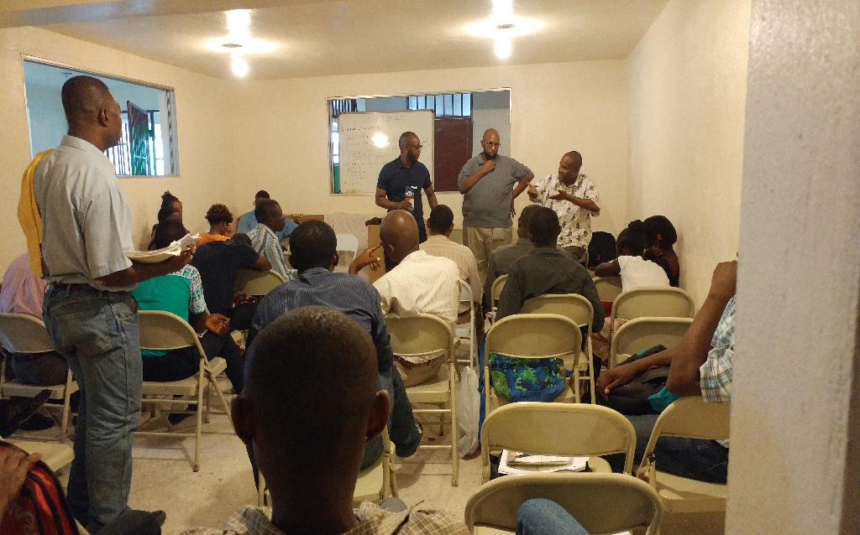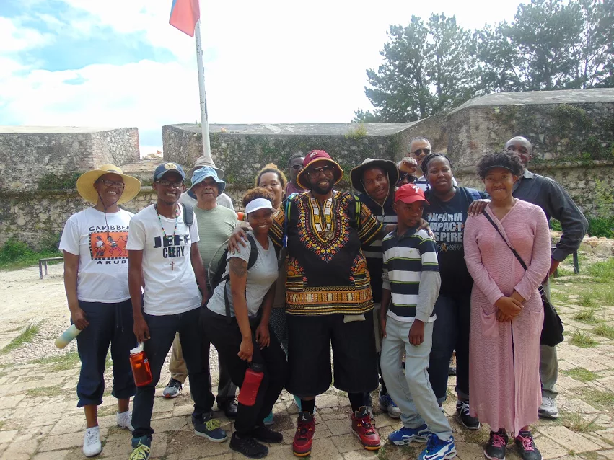

Solar Sytem for Ecole Gueny School is coming together

These batteries may not look like much, but they will help power the laptops and the Internet-in-a-Box which simulates working on the internet for the children and gives them access to books, Wikipedia articles in three languages, and Khan Academy videos.

Thanks to generous funding, the plan for a computer lab dedicated to the school is proceeding, although slower than hoped due to the illness of one of our volunteers. Please pray for Kent Hills’ continued recovery.

To date we have upgraded the school library door and secured the windows. We have four batteries and two solar panels and begun the hiring for installation of the solar panels as we move the computer lab to its new location in the school wing. We hope to have this done for the fall semester. We are also planning for expanding the classrooms to the bottom floor of the school building.

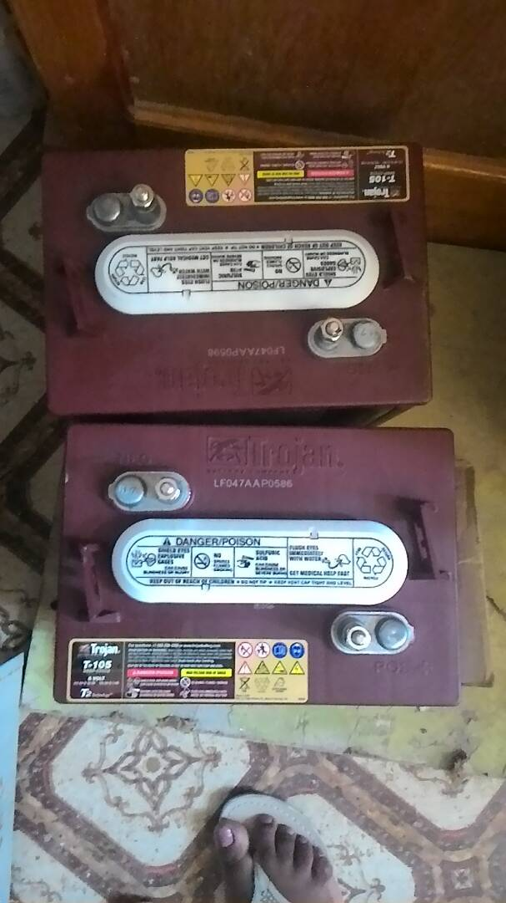

Donated Van has reached the port in St Marc, Haiti.

In our last newsletter we had received the bus and packed it up. In June David Graves drove it to Florida and Jean Filostin is currently working the van through customs in Haiti as he picks up the van.

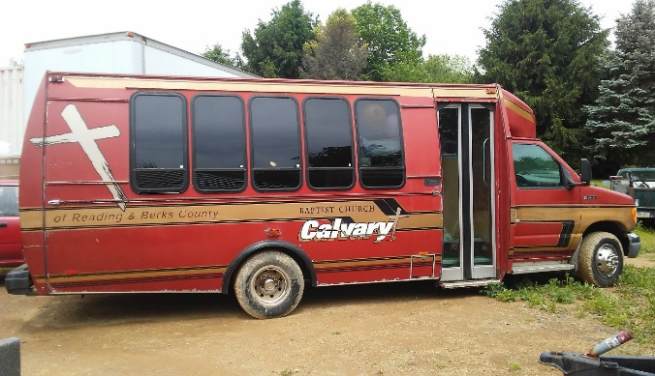

Please pray for our efforts. If you would like to donate toward the customs payment for the church bus, or ongoing support, any contribution will be greatly appreciated and can be sent to The Institute of Grace, PO Box 2364, Leesburg, VA 20177.

In His Service,

*David Graves* for the IOG; July 9, 2017